10.1-inch RFID Rugged Tablet
Equipped with Impinj ® E-series Core | Powerful Eight Core MT6789 | 10 meter Ultra Long Distance RFID Acquisition
Product Overview
The Y100 10.1-inch reinforced RFID tablet is a mobile workstation designed specifically for extremely harsh work environments. It not only has the smooth interaction of a consumer grade tablet, but also has industrial grade durability. The core is equipped with an MT6789 (Helio G99 level) eight core processor, combined with the latest Android 16 operating system, which can easily handle high-intensity industrial software operation and massive data concurrency.
The core competitive advantage of this device lies in its professional RFID reading and writing capabilities. Optional Impinj ® The E-series chip (performance benchmark) achieves outdoor ultra long distance reading of up to 10 meters, with a reading speed of over 150 tags per second. Combined with a 10000mAh ultra large capacity battery and 30W PD fast charging, it can provide uninterrupted power support in high-intensity asset inventory and warehouse management.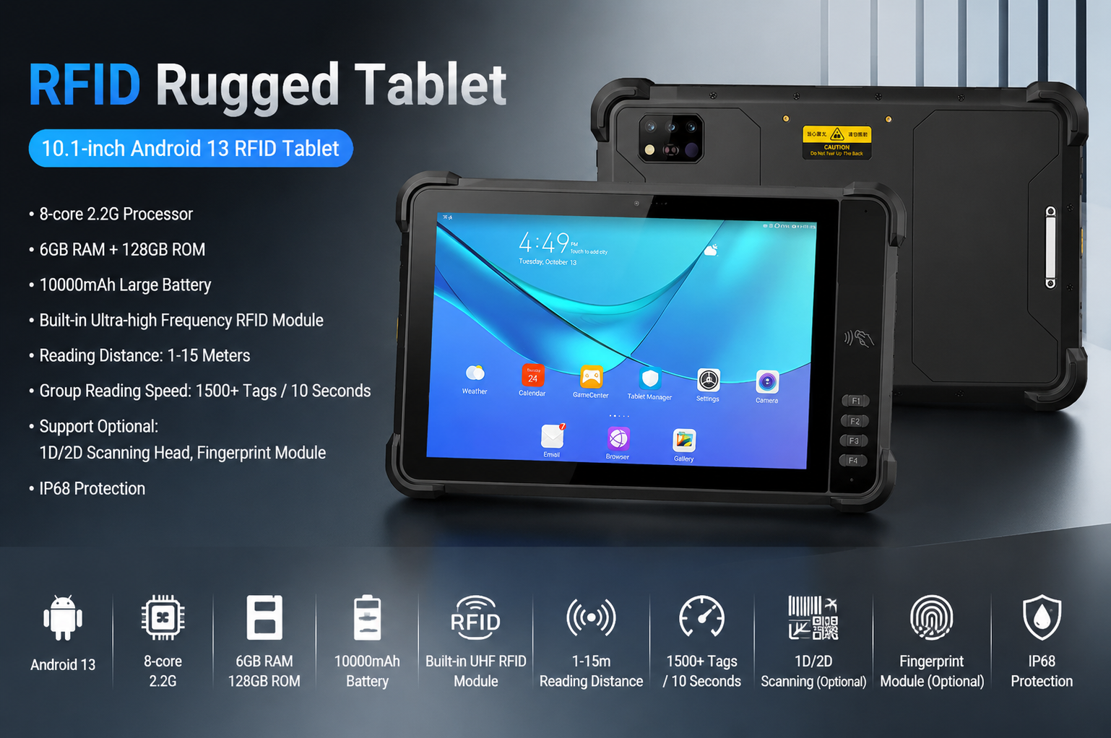

Key Highlights
Flagship level processing performance:
Using MT6789 eight core processor (2 × A76 @ 2.2GHz+6 × A55 @ 2.0GHz) to ensure zero latency for multitasking switching.
Comes standard with 8GB+128GB of large memory (up to 8GB+256GB optional), making it easy to handle complex database processing.
Top tier RFID collection capability in the industry:
Impinj ® E-series core module: supports global frequency bands (860-960MHz) and has a strong multi label collision algorithm.
Remote reading: Equipped with a 4dBi circularly polarized antenna, the reading distance can reach up to 10 meters in outdoor open environments.
Ultra fast group reading: can recognize 150+tags per second, greatly improving inventory efficiency.
Long lasting battery life and fast recovery:
10000mAh polymer lithium battery with a working time of over 10 hours.
Supports 30W PD fast charging, and can recover from zero charge to full charge in just 2-3 hours.
Professional level visual and interactive:
10.1-inch high-definition large screen: supports glove touch, allowing precise control even in severe cold or when wearing work gloves.
Rear high-definition camera: The rear 1600W pixel supports autofocus and fill light, making it easy to record details of on-site operations.
All day reinforced protection:
IP68 protection level: completely isolated from dust, supports immersion at a depth of 1 meter.
Anti drop design: capable of withstanding multiple drops from a height of 1.2 meters to a cement floor.
Wide temperature operation: Supports stable operation in extreme temperature difference environments ranging from -20 ℃ to 55 ℃.
Typical application scenarios (Target Applications)
Smart warehousing and location inventory: remote and large-scale reading of assets at high altitudes on shelves.
Power and energy inspection: Utilizing high-precision positioning and RFID tags for equipment lifecycle tracking.
Container logistics: Collecting and scheduling container labels in strong outdoor light and adverse weather conditions.
Manufacturing MES system: As a production line terminal, it performs material tracking and process data management.
Tech Specs Summary
Category key parameters
Processor/System MT6789 (8-core 2.2GHz)/Android 13
Memory/Storage 8GB RAM+128GB ROM (Supports up to 512GB expansion)
RFID module Impinj ® E710/E510/R2000 (optional)
Barcode scanning can be optionally equipped with a professional 1D/2D scanning engine (E60/CM60/N6603)
Battery/Charging 10000mAh/30W PD Fast Charging
Communication 4G full network/dual band WiFi/Bluetooth 5.0/full constellation positioning
Protection IP67, 1.2m Drop Resistance

Basic Information
processor | MT6789 (2 Arm) ® Cortex-A76 core, operating frequency of 2.2GHz, 6 Arm ® Cortex-A55 core, operating at a frequency of 2.0GHz
operating system | Android 16
Memory (RAM+ROM) | 8G+128G Optional:8G+256G
Expand memory | Micro SD card, supports up to 512GB
display | 10.1 inches, resolution: 800 * 1280 550 nits.  Optional: 10.1-inch/1920 * 1200/IPS 600nits/Supports glove mode/wet hand mode
Touch Screen | Capacitive screen: supports multi touch, glove touch
Rear camera | Rear 1600W pixels support autofocus and flash
Front Camera | Front 500W pixel (optional)
audio | Main MIC*1
audio | Speaker (4W) * 1
prompt | 2 RGB lights
prompt | Vibrating motors
keystroke | Left: Volume +-, Scan key  Right side: Power on button
External interfaces | Left: TYPC-A*1  Right side: SIM card holder + TF card holder, TYPC-C*1
sensor | Light sensing+distance, gravity sensor+6-axis gyroscope  Optional: Compass, air pressure sensor
battery | 10000 mAh polymer lithium battery,  Standby time> 350 hours  Working time> 10 hours (depending on the usage environment)
Charging method | Type-C 30W PD fast charging  The charging time is 2-3 hours, using the standard power adapter and data cable
Communication Transmission
WLAN function | Dual-band 2.4GHZ/5Ghz, support IEEE 802 a/b/g/n/ac protocol
Bluetooth | Supports Bluetooth 2.1+EDR/3.0+HS/4.1+HS+5.0
GNSS | Supports GPS, Galileo, Glonass, Beidou
Wireless WAN (Data Service) | GSM/GPRS/EDGE/CDMA/UMTS/HSPA/HSPA+/WCDMA/TD-SCDMA/TDD-LTE/FDD-LTE
Wireless WAN (Network Frequency) | 2G：GSM（B2/B3/B5/B8）  3G：WCDMA（B1/B2/B5/B8）  4G：FDD:B1/B2/B3/B5/B7/B8/B20/B25/B26/B28  TDD:B34/B38/B39/B40/B41
UHF RFID
Engine | module based on lmpinjE710
Engine | module based on lmpinj E510
Engine | module based on lmpinj indy R2000
Operating frequency | North America: 902-928MHz FCC (NA, SA)  Europe: 865-868MHz (ETSI)  China: 920-925MHz (CMIIT)  Full frequency range: 860-960MHz (OPEN )
Protocol | EPC global UHF Class 1 Gen 2 (ISO 18000-6C)
Antenna | Circular polarization, 4dBi
Power | 1W(30dBm, +5dBm to +30dBm adjustable)  2W Optional ( 33dBm, for Latin America, etc.)
Max Read Range | Up to 10 m (open outdoors, lmpinj MR6 tag)
Fastest Read Rate | 150+tags/sec
Optional functions
Barcode Scanning（optional）
Scan engine | E60\CM60\N1
1D Symbologies | UPC/EAN, Code128, Code39, Code93, Code11, Interleaved 2 of 5, Discrete 2 of 5, Chinese 2 of 5, Codabar, MSI, RSS, etc.
2D Symbologies | PDF417, MicroPDF417, Composite, RSS, TLC-39, Datamatrix, QR code, Micro QR code, Aztec, MaxiCode; Postal Codes: US PostNet, US Planet, UK Postal, Australian Postal, Japan Postal, Dutch, Postal (KIX), etc.
NFC（optional）
NFC | Operating frequency: 13.56MHz  Support agreement:：ISO14443A/B, ISO15693, NFC-IP1, NFC-IP2  Tag standard: M1 card(S50, S70), CPU card, NFC tag, etc  Reading and writing distance: 1-3cm
Environmental parameters
Operating temperature | -20℃~55℃  *For safety reasons, do not charge in a low temperature environment
Storage temperature | -40°C~70°C (without battery)
humidity | 0~95% (no condensation)
Drop Specs | The 1-meter concrete floor fell many times
Ingress protection | IP67
Electrostatic discharge | ±15KV (air discharge), ±8KV (contact discharge)
Development support
Development language | Java
Develop APIs | Android standard interface
Structural parameters
Dimensions (mm). | 290.6*182.5*18.5mm
Weight as standard | 980g
Equipment accessories
Standard accessories | Adapters, data cables, protective films

Due to irregular product updates, if there are any changes to the content, the actual shipment shall prevail.
Provide ODM and OEM customized services
• We work closely with our partners and can provide various one-stop customized solutions.
• Appearance customization: supports customization of product nameplates, product packaging, and promotional materials.
• Hardware customization: Supports customization of functional modules and optional hardware functions.
• Software customization: supports customization of boot interface, boot program, kernel clipping, and API interface.
• Technical support: Provide SDK development kits and application software development technical services.

